YES PROGRAM TERM 2, 2026
BE JOB READY IN HEALTH AND COMMUNITY SERVICES
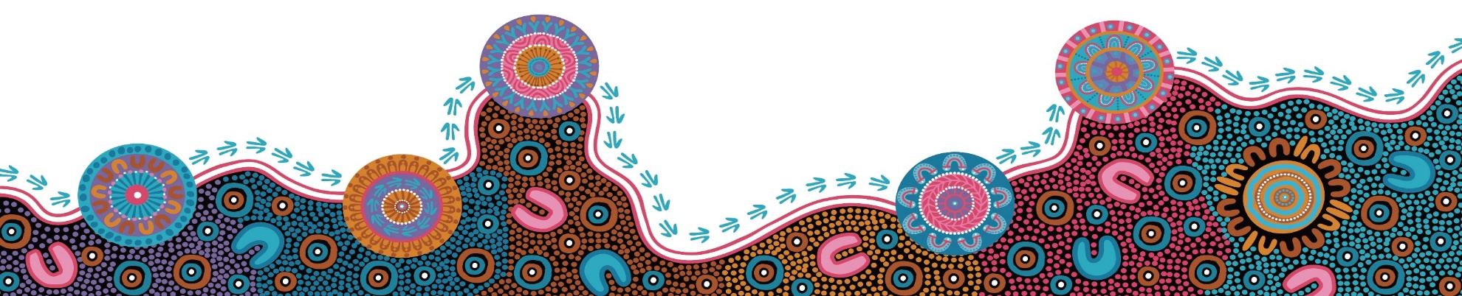

FOR MORE INFORMATION:
SWSLHD-AboriginalWorkforce@health.nsw.gov.au
Course description:
TAFE NSW’s Youth Engagement Strategy is designed to provide students with vocational learning in a hands-on environment. Students in this program will get to learn about the basics of nursing and health industry.

COURSE DURATION
8 consecutive days in Term 2 - commencing Monday 15th June 2026

COURSE LOCATION:
TAFE NSW Macquarie Fields
Community Services – Building M, 1st floor
32 Victoria Road, Macquarie Fields NSW 2564

TAFE NSW and South Western Sydney Local Health District are offering a YES Program in Health & Community Services for Aboriginal or Torres Strait Islander high school students to inspire and engage them in learning and build confidence to help with future career choices.

c
LEARNING OUTCOMES INCLUDE:
To successfully complete this program participants are required to attend and participate in each session.

The program will include information and skills development in the following work-based areas:
- Nursing & Acute Care
- Allied Health
- Dental Health
- Careers Beyond Clinical roles
- Future Pathways

During the 8-day program participants will learn about different health careers.
Hear from Aboriginal Health staff working at South Western Sydney Local Health District.

